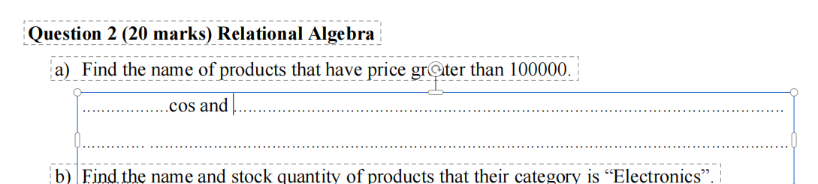

- /pi_{name} (/sigma_{price > 100000} (product))

 = /bowtie ( natural joint)

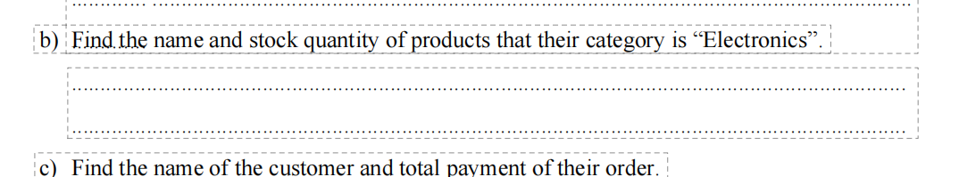
- /pi_{name, quantity} (/sigma_{name= 'elec..'} (Categories)/bowtie Products)

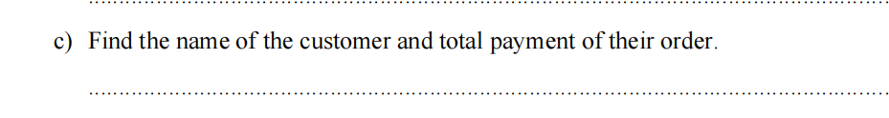
- /pi_{customer_name, total_payment} (customer/bowtie order)

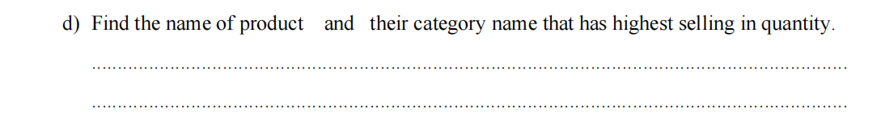
/pi_{P_name, C_Name} (/sigma_{quantity = MAX(quantity)} (product /bowtie category /bowtie order_fetail))

